Section 11-1: Areas of Parallelograms

SOL: G.10 The student will investigate and solve practical problems involving circles, using properties of angles, arcs, chords, tangents, and secants. Problems will include finding arc length and the area of a sector, and may be drawn from applications of architecture, art, and construction.

Objective:
Find perimeters and areas of parallelograms
Determine whether points on a coordinate plane define a parallelogram

Vocabulary: None New

Key Concepts:
If a parallelogram has an area of A square units, a base of b units and a height of h units then A = bh

Example 1: Find the perimeter and area of parallelogram ABCD
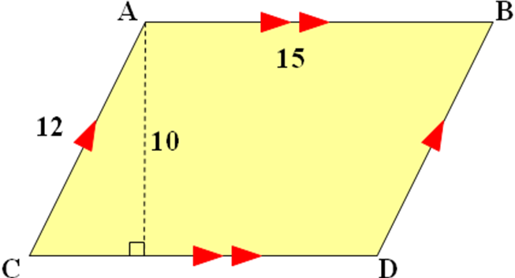

Example 2: Find the perimeter and area of parallelogram MNOP
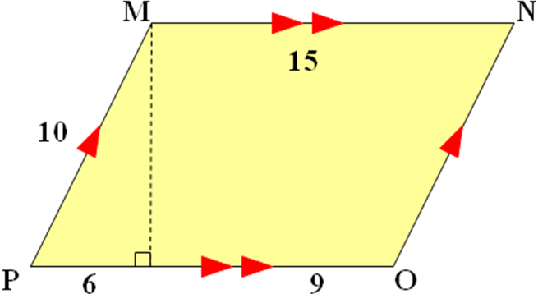

Example 3: Find the perimeter and area of parallelogram DEFG
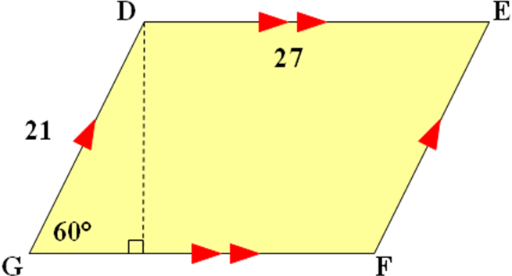

Concept Summary:
The area of a parallelogram is the product of the base and the height

Homework: pg 598-600; 9-16, 27, 28
Section 11-2: Areas of Triangles, Trapezoids, and Rhombi

SOL: G.14 The student will
a) use proportional reasoning to solve practical problems, given similar geometric objects; and
b) determine how changes in one dimension of an object affect area and/or volume of the object.

Objective:
Find areas of triangles
Find areas of trapezoids and rhombi

Vocabulary: None New

Theorems: Postulate 11.1: Congruent figures have equal areas.

Key Concepts:
If a triangle has an area of A square units, a base of b units and a corresponding height of h units then A = ½ bh
If a trapezoid has an area of A square units, a bases of b₁ and b₂ units and a height of h units then A = ½ (b₁ + b₂)h
If a rhombus has an area of A square units and diagonals of d₁ and d₂ units, then A = ½ d₁d₂

Example 1: Find the area of triangle RST:
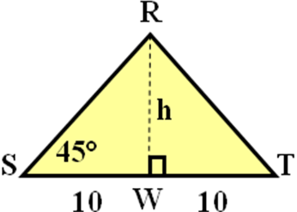

Example 2: Find the area of trapezoid JKLM:
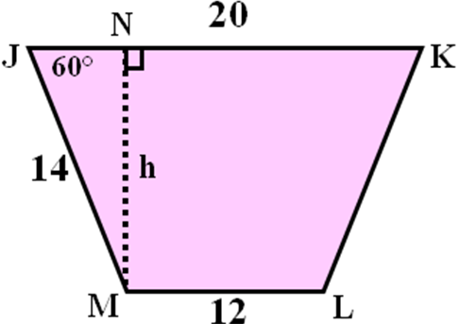

Example 3: Find the area of rhombus RST:
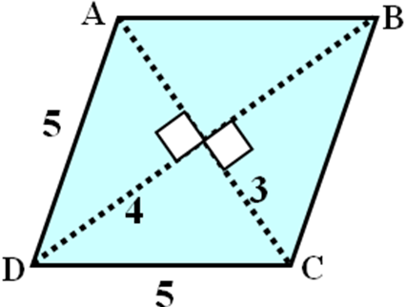

Concept Summary:
The formula for the area of a triangle can be used to find the areas of many different figures.
Congruent figures have equal areas.

Homework: pg 606-608; 13-18, 30-34

Section 11-3: Areas of Regular Polygons and Circles

SOL: G.14 The student will
a) use proportional reasoning to solve practical problems, given similar geometric objects; and
b) determine how changes in one dimension of an object affect area and/or volume of the object.

Objective:
Find areas of regular polygons
Find areas of circles

Vocabulary:
Apothem – perpendicular segment from center to side of a regular polygon

Theorems: None

Key Concepts:
If a regular polygon has an area of A square units, a perimeter of P units, and an apothem of a units, then A = ½ Pa
If a circle has an area of A square units and radius of r units, then A = πr²

Example 1: Find the area of circle S
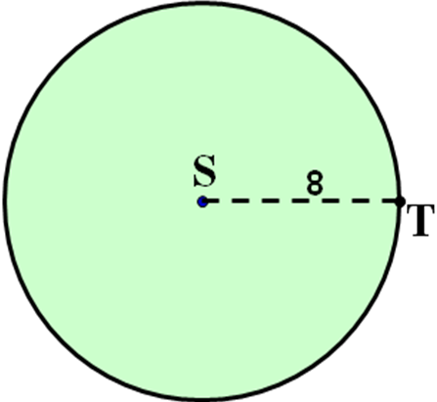

Example 2: Find the area of circle S, if RT = 20
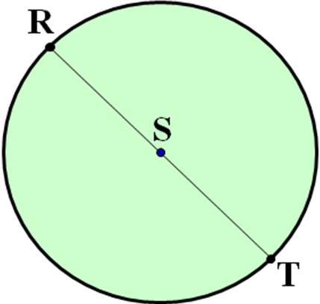

Example 3: Find the area of a hexagon, if the apothem is 4√3
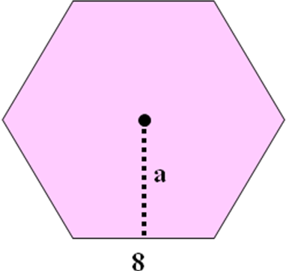

Example 4: Find the area of a hexagon
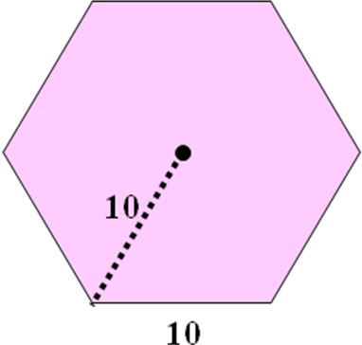

Concept Summary:
A regular n-gon is made up of n congruent isosceles triangles
The area of a circle of radius r units is πr² square units

Homework: pg 613-615; 14-22
Section 11-4: Areas of Irregular Figures

SOL: G.10 The student will investigate and solve practical problems involving circles, using properties of angles, arcs, chords, tangents, and secants. Problems will include finding arc length and the area of a sector, and may be drawn from applications of architecture, art, and construction.

Objective:
Find areas of irregular figures
Find areas of irregular figures on the coordinate plane

Vocabulary:
Irregular figure – a figure that can be classified into the specific shapes studied so far.
Irregular polygon – a polygon that is not regular (all sides and angles are not congruent)

Theorems:

Postulate 11.2: The area of a region is the sum of all of its nonoverlapping parts.

Example 1: Find the area of the irregular shape to the right
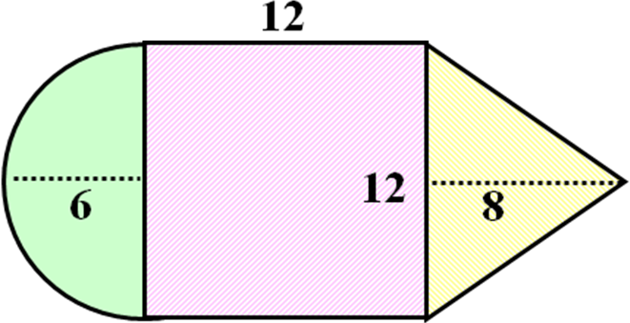

Example 2: Find the area of the field inside the track as pictured below (measurements in yards):
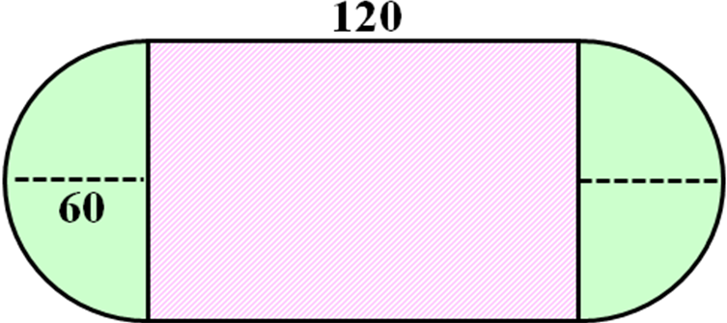

Concept Summary:
The area of an irregular figure is the sum of the areas of its nonoverlapping parts

Homework: pg 619-621; 3, 8-13
Section 11-5: Geometric Probability

SOL: G.10 The student will investigate and solve practical problems involving circles, using properties of angles, arcs, chords, tangents, and secants. Problems will include finding arc length and the area of a sector, and may be drawn from applications of architecture, art, and construction.

Objective:
Solve problems involving geometric probability
Solve problems involving sectors and segments of circles

Vocabulary:
Geometric Probability – probability involving geometric measure such as length or area
Sector – of a circle is bounded by a central angle and its intercepted arc
Segment – region of a circle bounded by and arc and a chord

Theorems: None

Key Concepts:
If a point in region A is chosen at random, then the probability P(B) that the point is in region B, which is in the interior of region A, is P(B) = (area of region B) / (area of region A)
If a sector of a circle has an area of A square units, a central angle measuring N°, and a radius of r units, the A = (N°/360) πr²

Example 1: What is the probability of landing in a circle surrounded by a square?
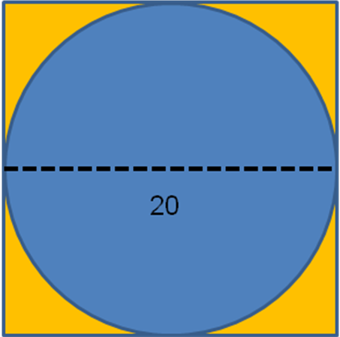

Example 2: Given the spinning wheel to the right:
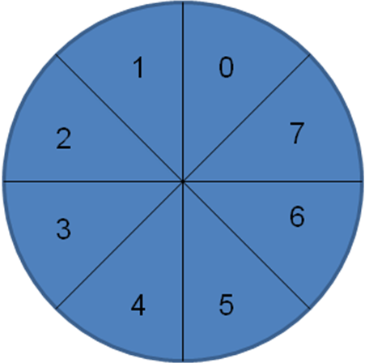
- Find the probability of landing on an odd number?

- Find the probability of landing on zero?

- Find the probability of landing on an even number?

Concept Summary:
To find geometric probability, divide the area of a part of a figure by the total area

Homework: pg 625-627; 10-15
Lesson 11-1 5-minute Check
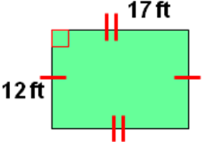
Find the area and the perimeter of each parallelogram. Round to the nearest tenth if necessary.
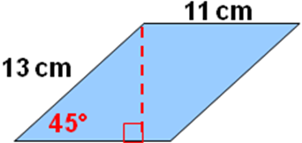
- 2.

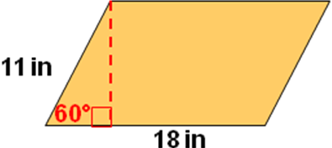
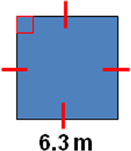
3. 4.

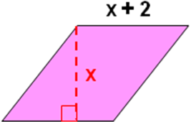
5. Find the height and base of this parallelogram, if the area is 168 square units
6. Find the area of a parallelogram if the height is 8 cm and the base length is 10.2 cm.
A. 28.4 cm² B. 29.2 cm² C. 81.6 cm² D. 104.4 cm²

Lesson 11-2 5-minute Check
Find the area of each figure. Round to the nearest tenth if necessary.
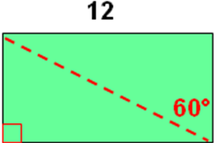
- 2.
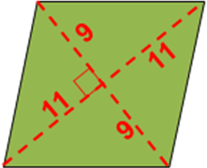

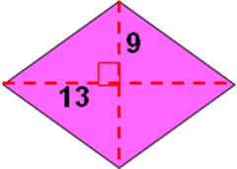
3. 4.
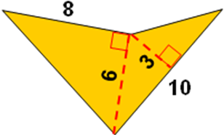

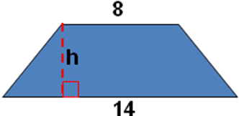
5. Trapezoid LMNO has an area of 55 square units. Find the height.

6. Rhombus ABCD has an area of 144 square inches. Find AC if BD = 16.
A. 8 in B. 9 in C. 16 in D. 18 in
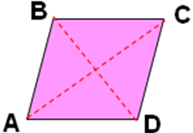

Lesson 11-3 5-minute Check
Find the area of each regular polygon. Round to the nearest tenth if necessary.
- A hexagon with side length 8 cm.
- A square with an apothem length of 14 in.
- A triangle with a side length of 18.6 m.
Find the area of each shaded region. Assume all polygons
are regular. Round to the nearest tenth if necessary.
4. 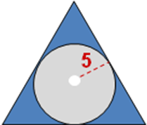 5. 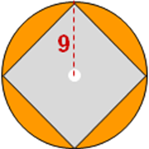
6. Find the area of a circle with a diameter of 8 inches.
A. 4π B. 8π C. 16π D. 64π

Lesson 11-4 5-minute Check
Find the area of each figure. Round to the nearest tenth if necessary.
1. 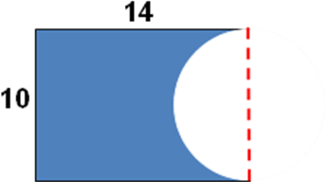 2. 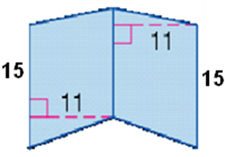

3. 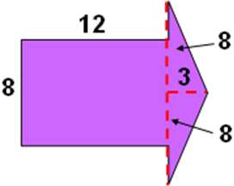 4. 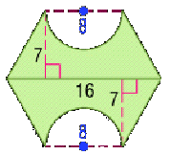

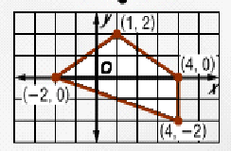

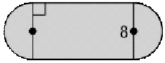
5. Find the area of the figure
6. Find the figure’s area.
A. 112 units² B. 136.8 units² C. 162.3 units² D. 212.5 units²

